# MASTER SHEET IMPORT | GUIDELINES

Contents

MASTER SHEET IMPORT | GUIDELINES 1

How to Generate a new Batch? 2

How to Update Information of the Batch? 4

How to Upload Excel Sheet of Batch? 6

How to Fill the Batch Master Sheet – Excel ? 8

## 

## How to Generate a new Batch?

1. Click on the button Generate Batch ID

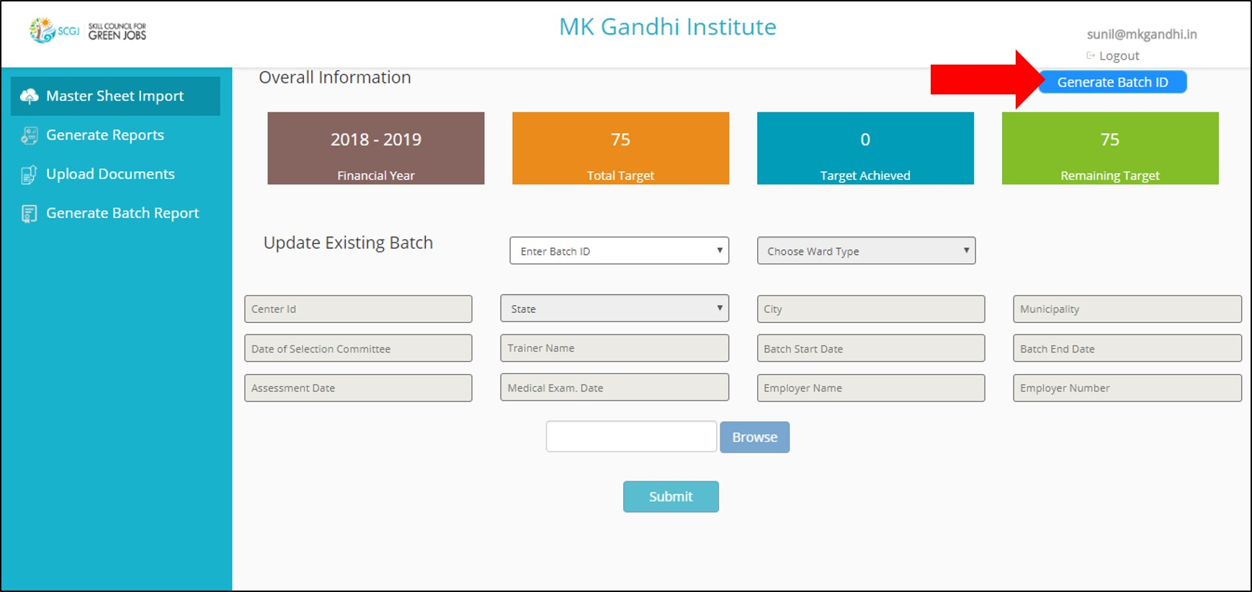

1. Save the Batch Master Sheet in the system.
2. An Excel Sheet would be generated for the batch id, click it to open

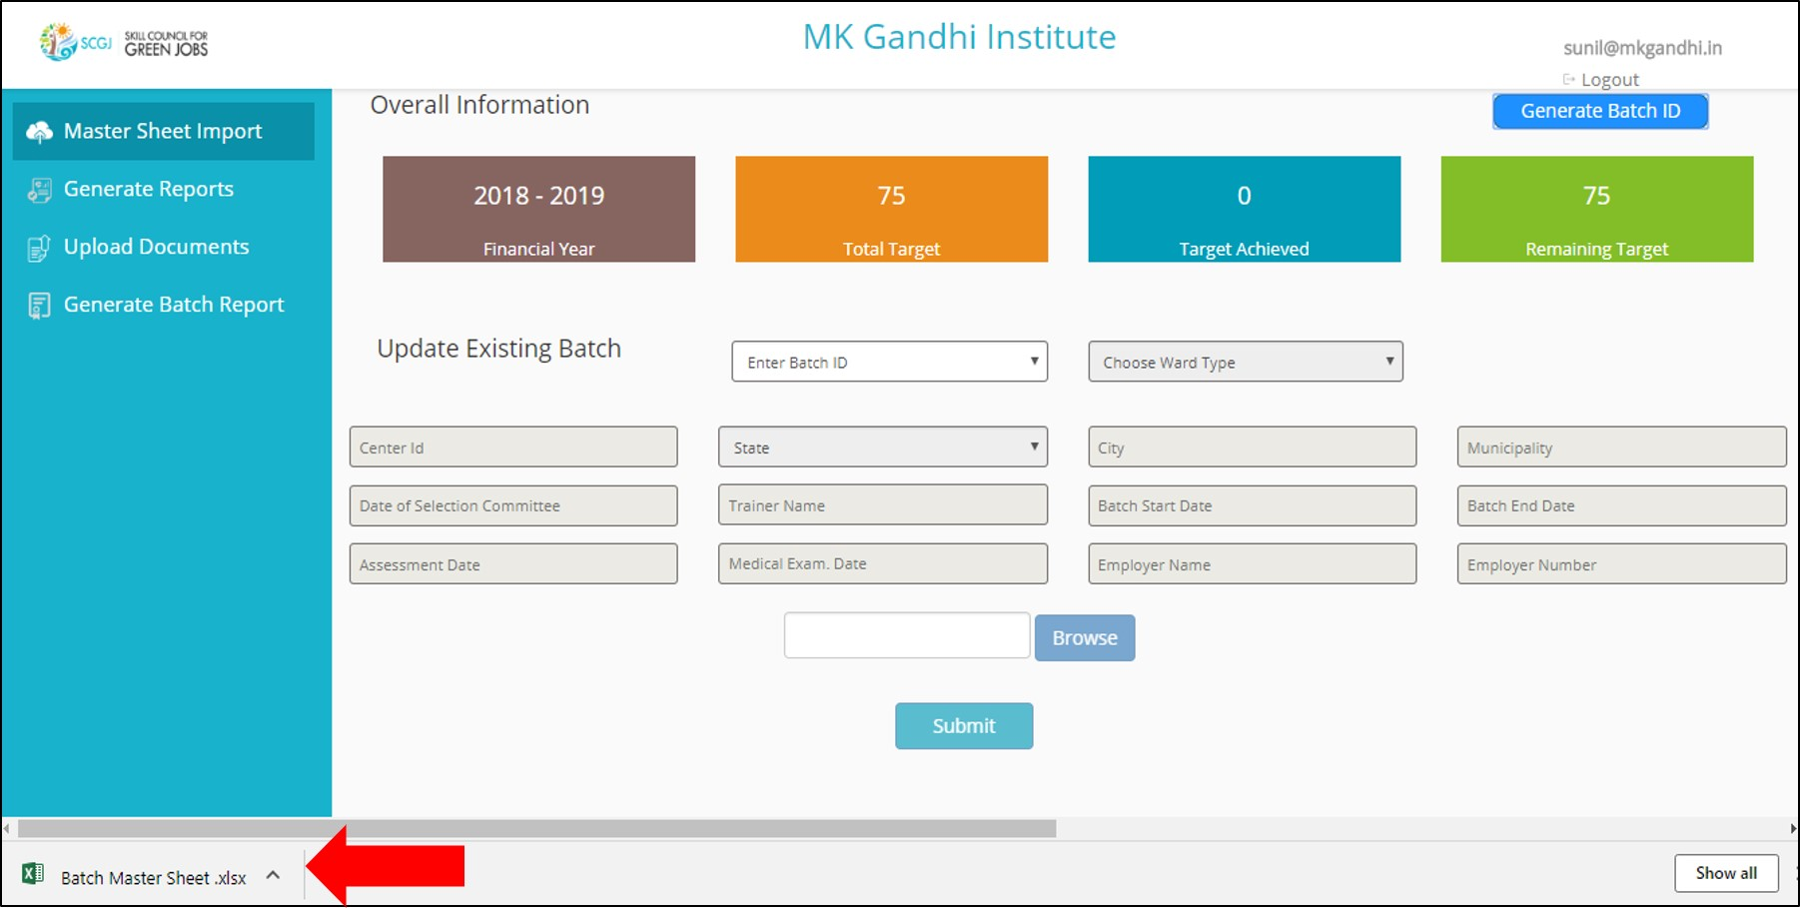

1. Excel Sheet would have the batch id, NSDC Registration Number, Training Partner name, job role & name of sector Skill Council. Defined columns to store candidate information for the respective batch.

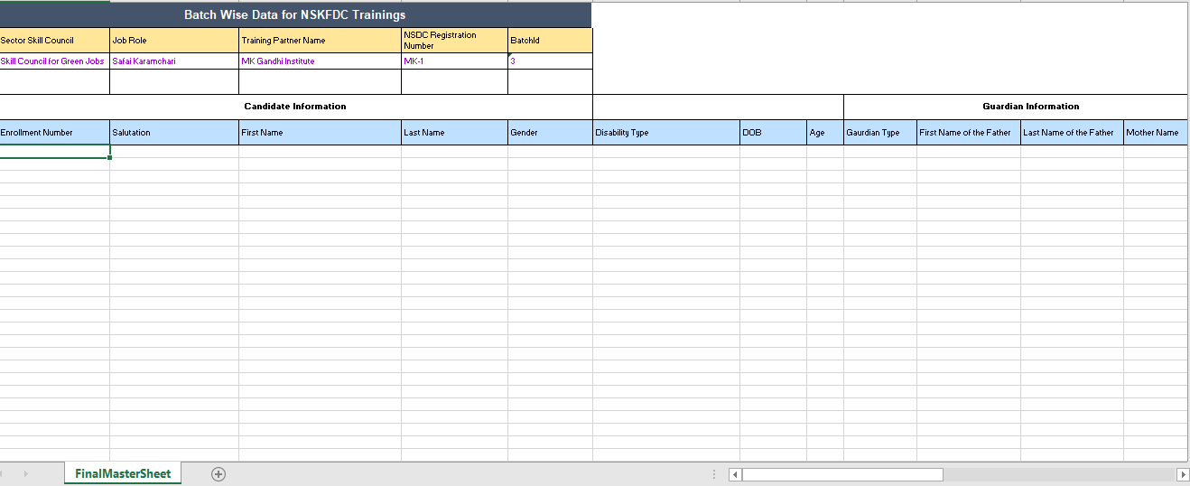

In the above sheet, the information can be filled for the batch generated by Training Partner.

## How to Update Information of the Batch?

1. Click on the dropdown (Enter Batch Id) & select batch id to be updated

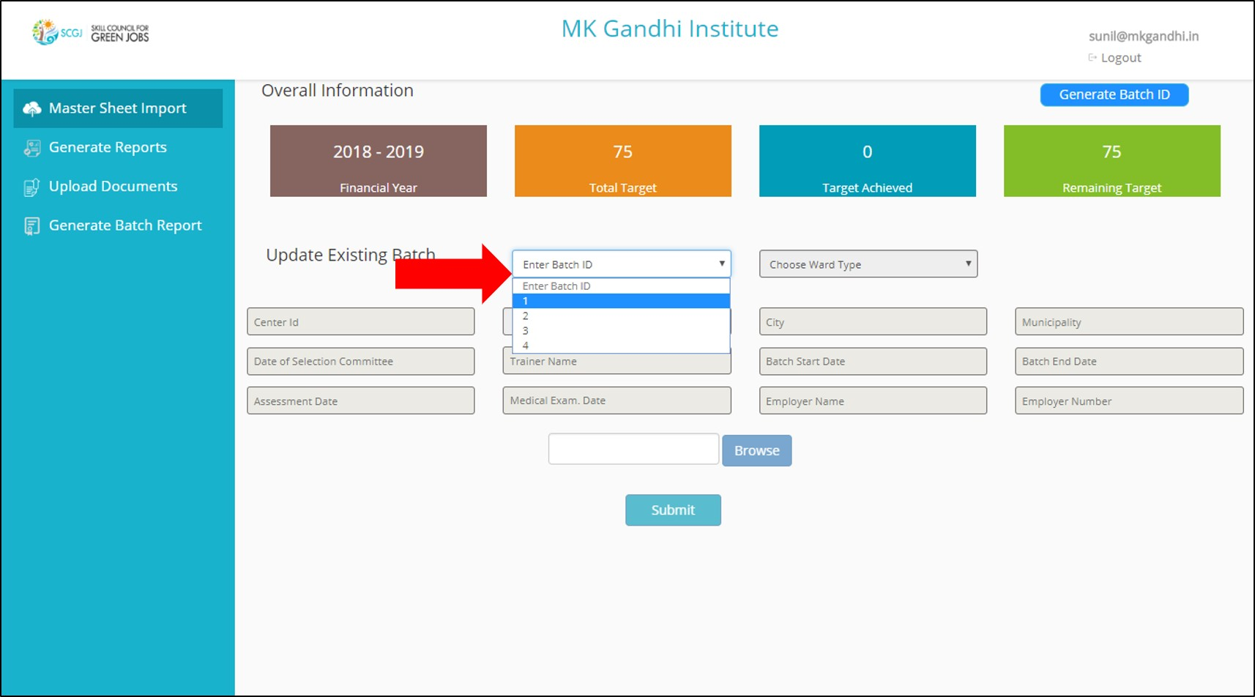

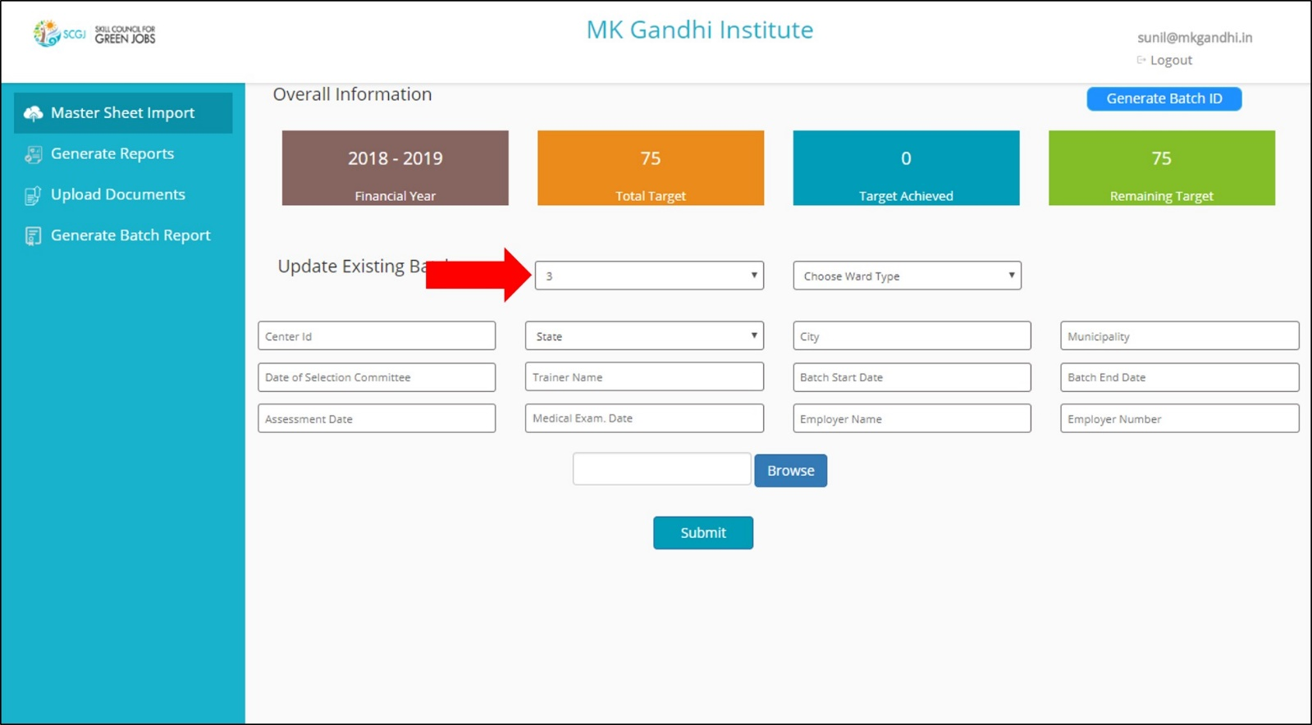

1. After the batch Id is selected then only Training Partner can update any information of the batch.
2. Now, Training partner can update the following information of batch:

* Ward Type – Single (Enter ward number) / Multiple
* Centre Id – numeric value
* State – select from dropdown
* City
* Municipality
* Date of selection committee – mm/dd/yyyy
* Trainer Name
* Batch Start Date – mm/dd/yyyy
* Batch End Date – mm/dd/yyyy
* Assessment Date – mm/dd/yyyy
* Medical Exam Date – mm/dd/yyyy
* Employer Name
* Employer Number – Phone number

Centre Id, State, City, Municipality are mandatory fields to submit.

1. Click on Submit Button, to update & save the data.

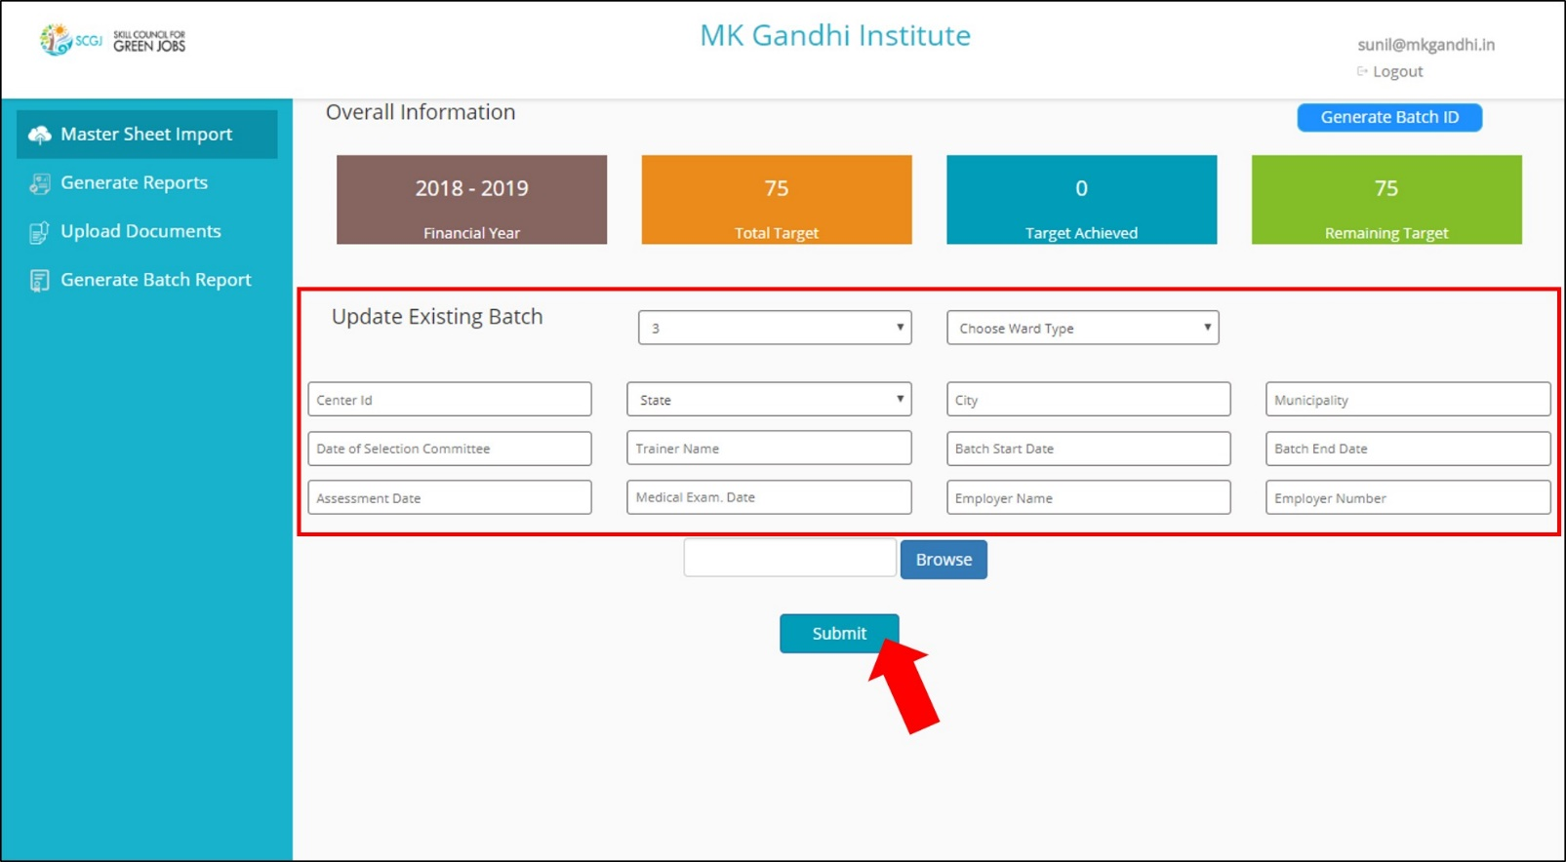

## How to Upload Excel Sheet of Batch?

1. Select batch Id to be updated.



1. Enter Centre id, State, City and Municipality
2. Click on Browse and select the excel sheet to be uploaded

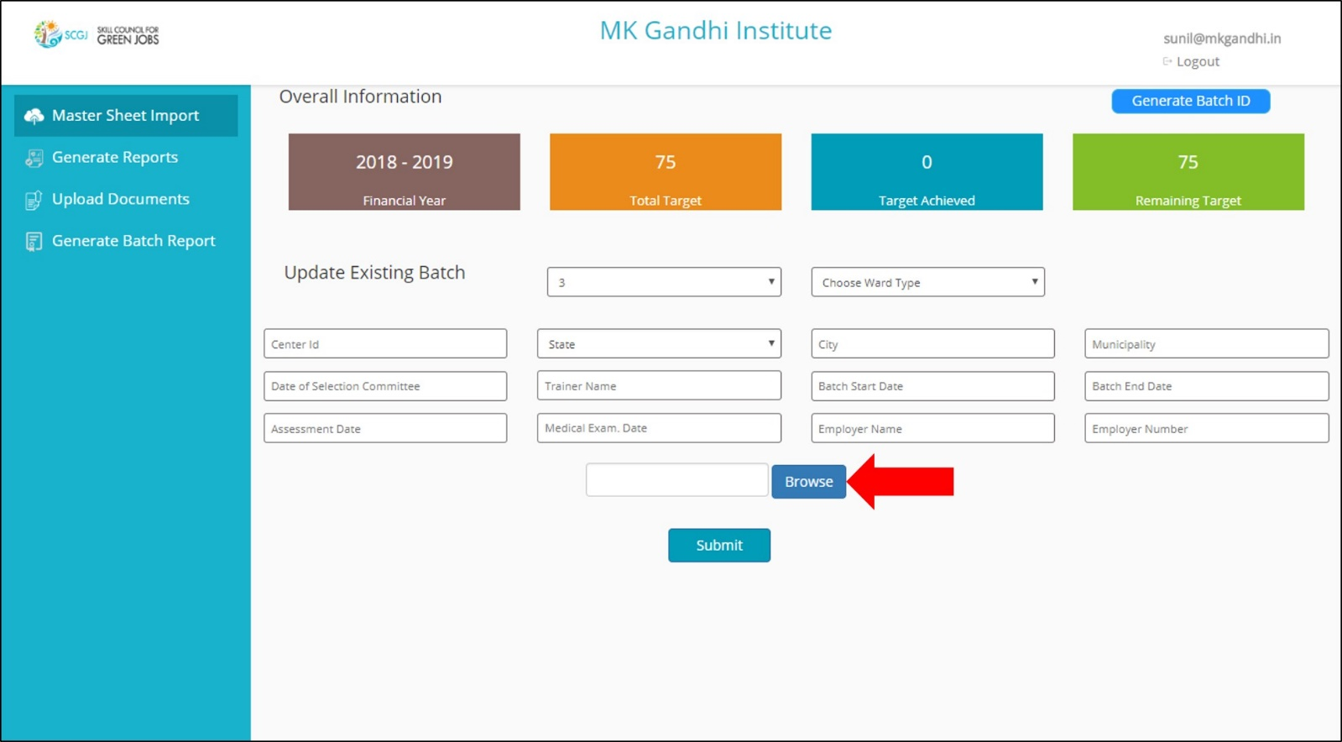

1. Select the File to be uploaded & click Open

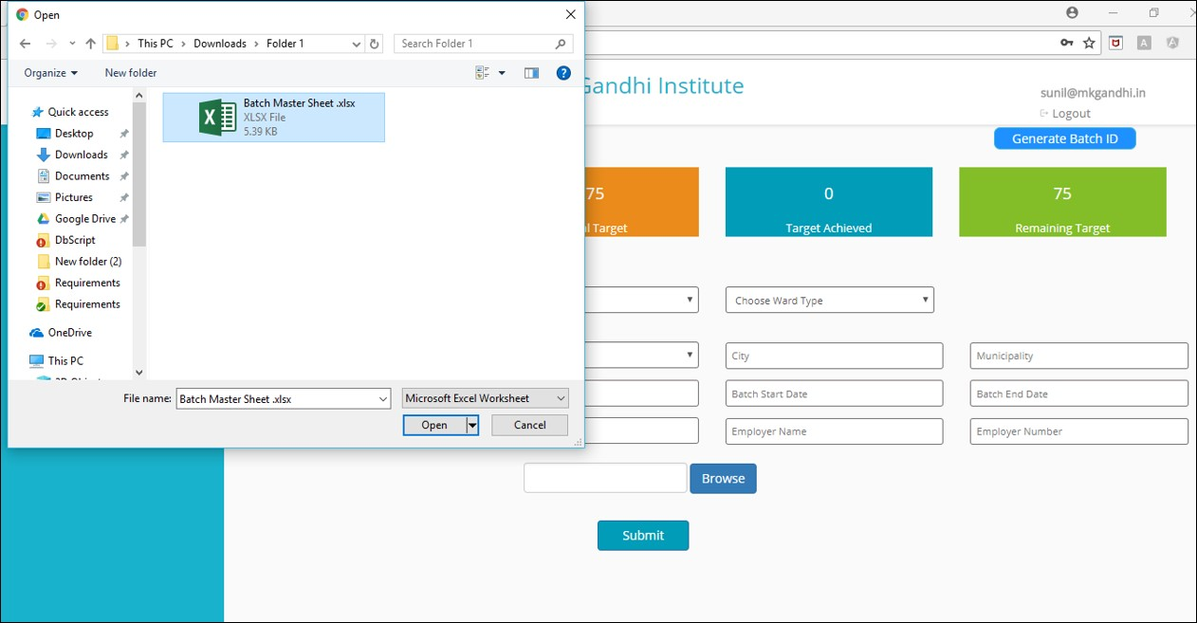

1. Batch Id should be same in the Excel Sheet as well as in the dropdown.

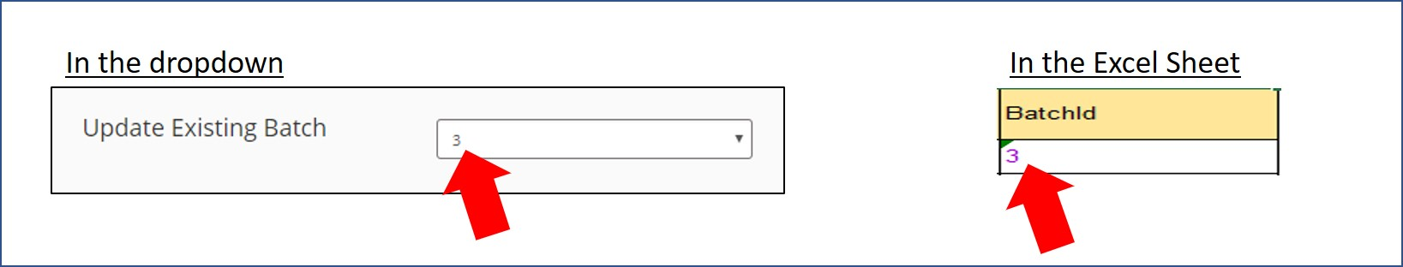

## How to Fill the Batch Master Sheet – Excel ?

1. Open the excel sheet of batch that needs to be edit.
2. DO NOT Edit already written columns of the sheet. (Row 1 to 6)

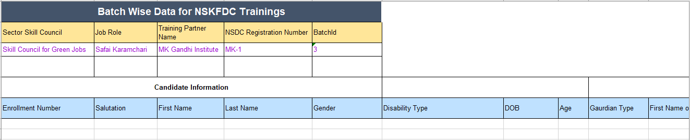

1. Start filling the sheet from Row 7
2. Mandatory Columns to upload the excel sheet are:

* Enrollment Number
* Salutation
* First Name
* Gender
* DOB
* Age
* State
* Aadhar Card Number

(Any candidate data can be updated only when the above fields are entered).

1. Training Partner can update the data in the excel sheet & submit the data again.
2. DOB in the sheet should have the date Format. To do that:
3. Right click on column G

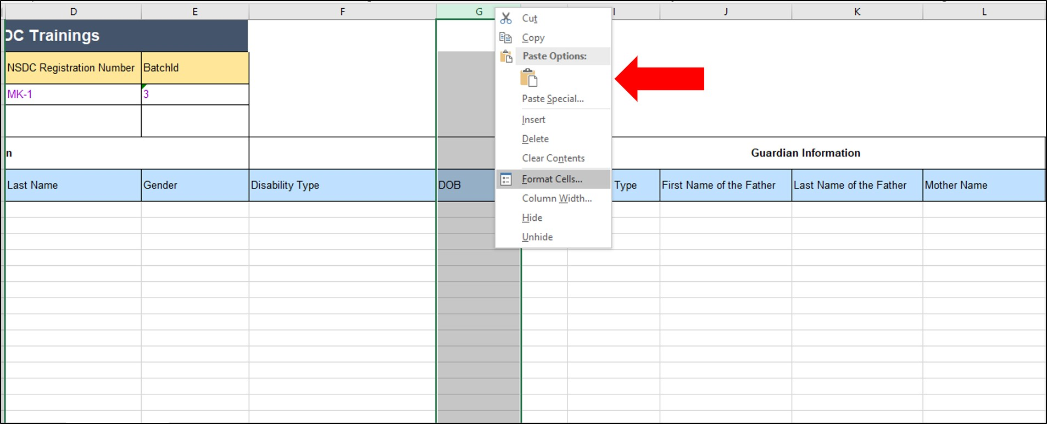

1. Select Format Cells
2. Select Date & type = 2012-03-04 & Click Ok.

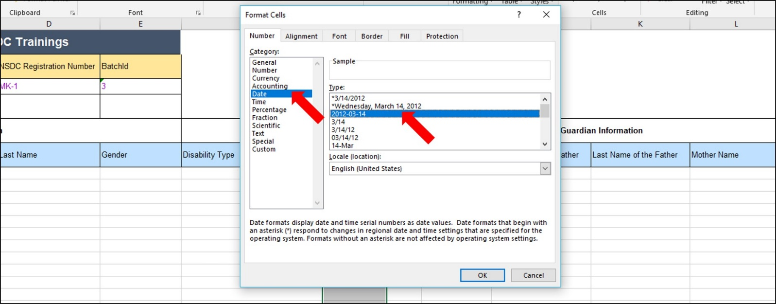

1. Mobile number column in sheet should have number format: To do that:
   1. Right click on column M

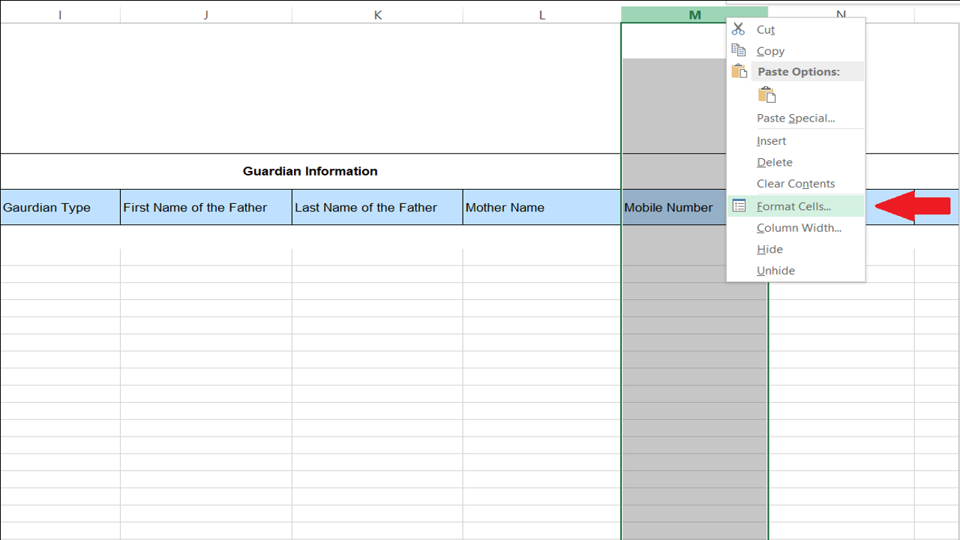

* 1. Select Format Cells

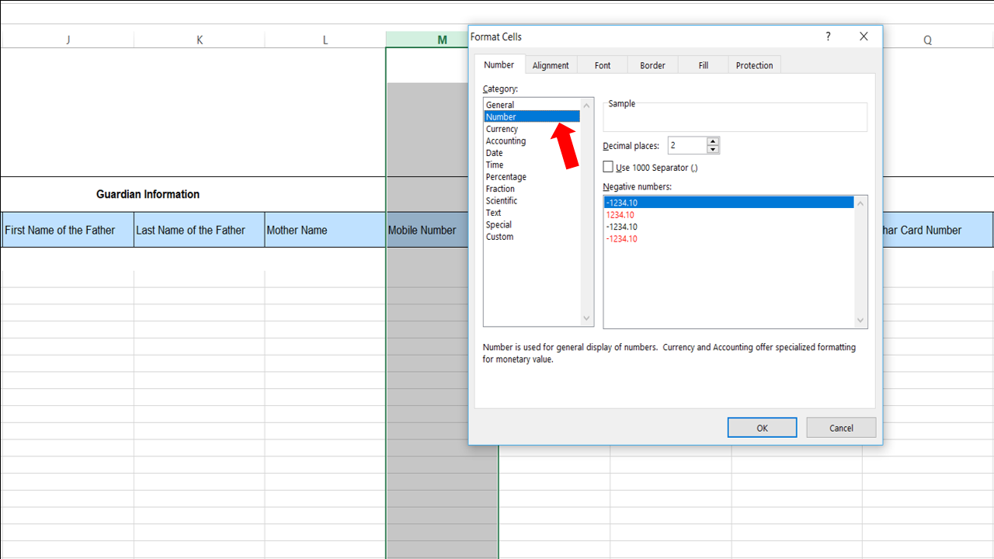

* 1. Select Number & Click Ok.

1. Now fill the details of candidates in the sheet & Upload it in the module.
2. And click on Submit.